From Pipeline Failure to Root Cause in Minutes

**Using Kiro's AWS Observability Power and HealthOmics Power to Investigate and Resolve Genomic Workflow Failures Directly in Your IDE**

*Author: Avinash Gogineni, ESL TAM – AWS HCLS*
*Date: March 2026*
*Audience: Bioinformatics Engineers, Genomics Platform Teams, AWS Blog Readers*

---

## Introduction

Genomic sequencing pipelines are mission-critical. When a variant calling workflow fails at 2 AM — hours before a clinical reporting deadline — every minute of downtime carries real consequences for patients and diagnostic teams alike. Traditionally, a bioinformatician would pivot between the AWS Console, CloudWatch Logs Insights, and scattered runbooks to piece together what went wrong. That process could take hours.

Kiro changes this entirely.

With the AWS HealthOmics Power and the AWS Observability Power installed in Kiro, a developer can open a single IDE session and immediately begin a natural language conversation with their infrastructure. Ask Kiro why a workflow run failed, and it queries CloudWatch manifest logs, surfaces the exact task that errored, and identifies the root cause — whether it's a misconfigured ECR image URI, an IAM permission boundary, or a resource exhaustion event on a specific run task. No tab-switching. No manual log parsing. No waiting for a dashboard to refresh.

The AWS Observability Power brings together CloudWatch metrics and alarms, Application Signals for distributed tracing, and CloudTrail for audit context — all accessible through Kiro's AI agent interface. The HealthOmics Power adds deep workflow-specific intelligence: understanding run states, task-level resource utilization, and optimization recommendations. Together, they create a closed-loop troubleshooting experience where the IDE becomes the command center for both development and operations.

For genomics teams running high-throughput sequencing pipelines — processing thousands of samples per day across WGS, WES, and targeted panel workflows — this shift from reactive firefighting to proactive, AI-assisted resolution is transformative. What once required a senior engineer and two hours of investigation now takes minutes, directly inside the tool where the pipeline was built.

This is the future of bioinformatics operations: intelligent, IDE-native, and built for the pace of precision medicine.

---

## Technical Architecture

The solution is built on three integrated layers: the Kiro IDE, AWS HealthOmics, and the AWS Observability stack. Together, they form a closed-loop, AI-assisted pipeline operations environment.

### Architecture Overview

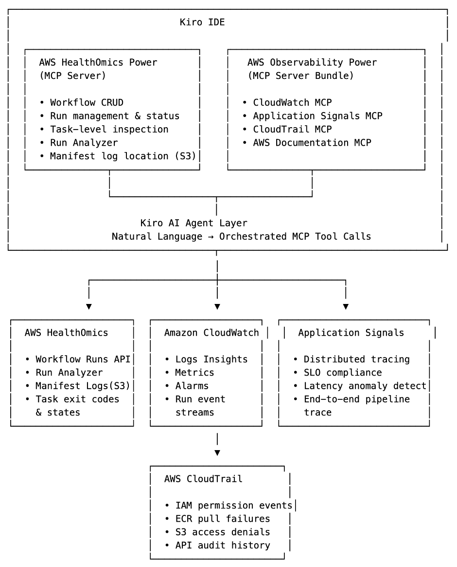

### Layer 1: Kiro IDE with Installed Powers

The developer's entry point is the **Kiro IDE**, with two Powers installed:

- **AWS HealthOmics Power** (`github.com/kirodotdev/powers/tree/main/aws-healthomics`): Exposes HealthOmics APIs as MCP tools, enabling Kiro's AI agent to list workflow runs, inspect run states, retrieve task-level resource utilization from the Run Analyzer, and surface manifest log locations in S3.

- **AWS Observability Power** (`kiro.dev/launch/powers/aws-observability`): Bundles four MCP servers — CloudWatch, Application Signals, CloudTrail, and AWS Documentation — giving the AI agent access to logs, metrics, alarms, distributed traces, and audit history through natural language queries.

When a developer types *"Why did run omics-abc123 fail?"*, Kiro's AI agent orchestrates tool calls across both Powers to construct a complete answer.

### Layer 2: AWS HealthOmics — Workflow Execution & Run Data

AWS HealthOmics serves as the execution engine for genomic workflows (Nextflow, WDL, CWL). Key data surfaces consumed by the Kiro agent include:

- **Run status and task-level details** via the HealthOmics Runs API — surfaces which specific task failed, its exit code, and the container image used.
- **Run Analyzer output** — provides CPU, memory, and storage utilization per task, enabling identification of over- or under-provisioned resources.
- **Manifest logs stored in S3** — contain detailed execution logs per workflow task, including stdout/stderr from containerized tool invocations (e.g., GATK HaplotypeCaller, BWA-MEM2).

### Layer 3: AWS Observability Stack — Signals, Traces, and Audit

The Observability Power connects Kiro to four complementary data sources:

- **CloudWatch Logs & Metrics**: Captures HealthOmics workflow run events, Lambda invocation logs, and custom metrics such as samples-per-hour throughput.
- **CloudWatch Alarms**: Pre-configured alarms on run failure rates, task retry counts, and queue depth trigger proactive alerts surfaced directly in the IDE.
- **Application Signals**: Provides end-to-end distributed tracing across the full pipeline invocation chain — from the S3 event trigger through Lambda orchestration into HealthOmics — enabling identification of latency bottlenecks outside the workflow engine itself.
- **CloudTrail**: Surfaces IAM permission errors, ECR pull failures, and S3 access denials that are common root causes of HealthOmics workflow failures but invisible within the HealthOmics console alone.

---

## Troubleshooting Workflow: A Step-by-Step Example

Consider a WGS variant calling pipeline that fails during the `HaplotypeCaller` task:

1. **Alert fires**: A CloudWatch Alarm on `HealthOmics/WorkflowRunFailed` triggers and is surfaced in Kiro via the Observability Power.
2. **Developer queries Kiro**: *"What failed in the last HealthOmics run and why?"*
3. **HealthOmics Power**: Retrieves the run ID, identifies the failed task (`HaplotypeCaller`), and fetches the manifest log location from S3.
4. **CloudWatch MCP**: Queries the manifest log for the task's stderr output — surfaces an `OutOfMemoryError` with the container's memory limit.
5. **Run Analyzer data**: Confirms the task was allocated 16 GiB but required 28 GiB based on the input BAM file size.
6. **Kiro AI agent synthesizes**: *"Task HaplotypeCaller failed due to memory exhaustion. The run was configured with 16 GiB; Run Analyzer recommends 32 GiB for this input size. Update the workflow memory parameter and re-run."*
7. **Developer applies the fix**: Updates the workflow definition file — already open in Kiro — and re-submits the run.

**Total time from alert to resolution: under 10 minutes, without leaving the IDE.**

---

## Prerequisites & Setup

To replicate this architecture, you will need:

- **Kiro IDE** installed (kiro.dev)
- **AWS HealthOmics Power** installed from the Kiro Powers marketplace
- **AWS Observability Power** installed from kiro.dev/launch/powers/aws-observability
- An **AWS HealthOmics private workflow** with CloudWatch logging enabled (`logLevel: ALL` recommended for troubleshooting)
- **IAM permissions** for the Kiro session role: `omics:GetRun`, `omics:ListRunTasks`, `logs:StartQuery`, `cloudtrail:LookupEvents`, `xray:GetTraceSummaries`
- An **S3 bucket** configured as the HealthOmics run output location, with manifest logs enabled

---

## Conclusion

The combination of Kiro's AWS HealthOmics Power and AWS Observability Power represents a fundamental shift in how genomics engineering teams operate production pipelines. By bringing CloudWatch logs, Run Analyzer insights, distributed traces, and audit history into a single AI-assisted IDE session, teams can compress hours of reactive troubleshooting into minutes of conversational investigation.

For organizations running clinical-grade genomic pipelines — where pipeline reliability directly impacts patient outcomes and reporting SLAs — this architecture offers both operational resilience and a dramatically improved developer experience.

The sample code and Kiro Power configurations referenced in this post are available at:

- `github.com/kirodotdev/powers/tree/main/aws-healthomics`
- `aws-samples/sample-enhanced-monitoring-and-observability-for-aws-healthomics-workflows`

